**Adobe Photoshop CC**

**Class Project**

Hi There,

After complete the project don’t forget to upload your project result in a JPEG version in:

* Project Section.
* Comments of the project video.

**Class Project 1: Change Banana Color Yellow To Green**

1. **Image:** Use image from exercise file or you can use your own or you can get it from unsplash.com
2. **Duplicate Layer:** Duplicate background layer in layer panel
3. **Use Hue & Saturation:** Use Hue & Saturation for change color
4. **Output:** Save the image in JPEG format

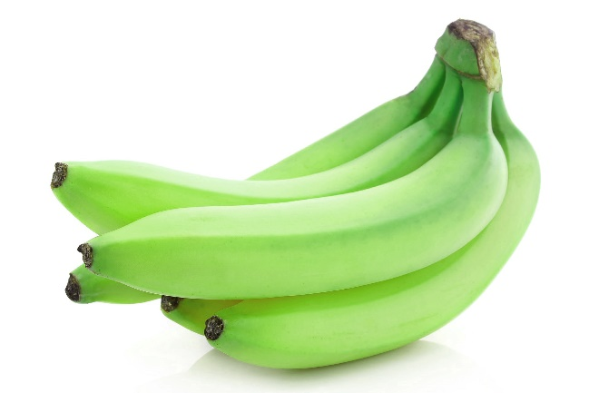

**Class Project 2: Remove First Ten Orange Using Content Aware**

1. **Image:** Use image from exercise file or you can use your own or you can get it from unsplash.com
2. **Duplicate Layer:** Duplicate background layer from layer panel
3. **Rename Layer:** Rename the layer “Content Aware”
4. **Lasso Tool:** Use lasso tool for making selection of oranges
5. **Content Aware Fill:** Use content aware fill for remove subject
6. **Output:** Save the image in JPEG format

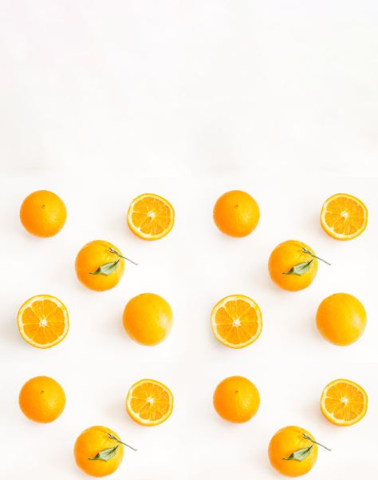

**Class Project 3: Create Gradient, Stroke, Bevel and Emboss in Text**

1. **Text:** Use Type Tool for type a text. You can type your name for practice.
2. **Blending Option:** Select Text Layer and use blending option for add Gradient.
3. **Apply Gradient:** Use any presets for apply blending, or you can use any color.
4. **Blending Option:** Select Text Layer and use blending option for add Stroke
5. **Apply Stroke:** Use 10 px stroke on text and please make sure color of stroke is black.
6. **Blending Option:** Select Text Layer and use blending option for add Bevel & Emboss
7. **Apply Bevel & Emboss:** Use Inner Style and set depth, size and soften.
8. **Output:** Save the image in JPEG format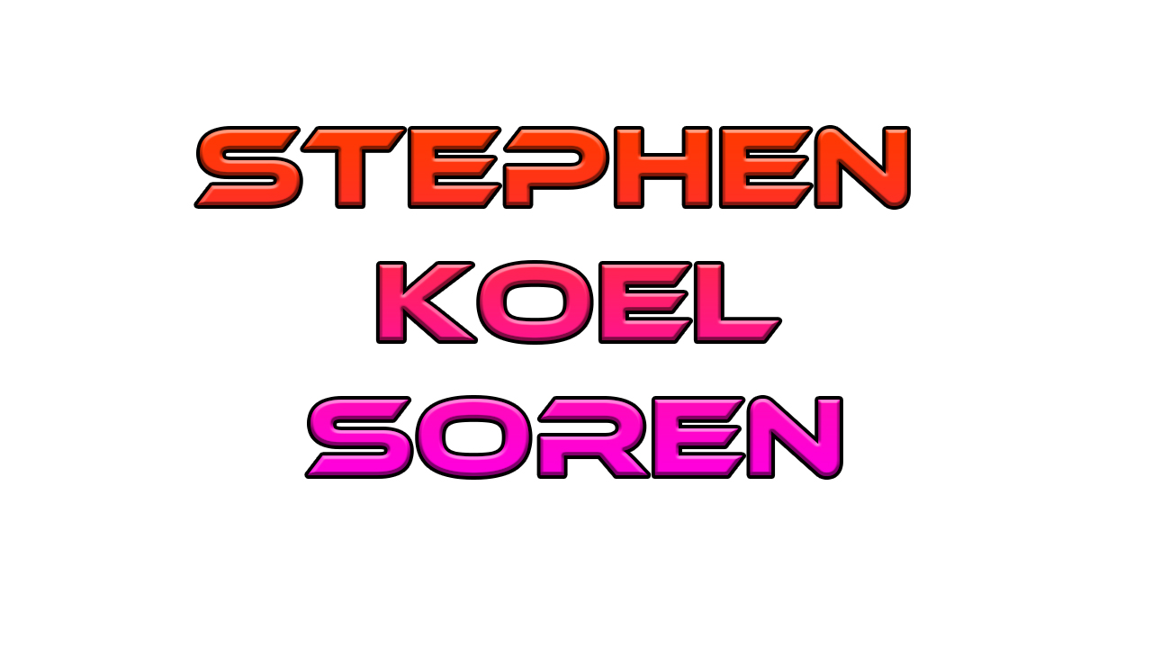

**Class Project 4: Add Drop Shadow**

1. **Image:** Place image from exercise file or you can use your own created image or you can use unsplash.com
2. **Duplicate Layer:** Duplicate background layer from layer panel
3. **Rename Layer:** Rename the layer “Shadow”
4. **Selection:** Use quick selection tool for make a selection
5. **Add Layer Mask:** Add a layer mask for shadow layer
6. **Apply Drop Shadow:** Use blending option and use drop shadow. Set distance, spread, size and reduce opacity.
7. **Output:** Save the image in JPEG format

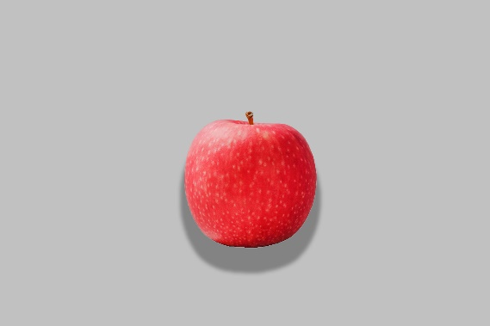

**Class Project 5: Text Interaction With Leaf**

1. **Image:** Use image from exercise file or you can use your own created image or you can use unsplash.com
2. **Text:** Use type tool for type text (write your name as example)
3. **Duplicate Layer:** Duplicate background layer
4. **Selection:** Use quick selection tool for make selection of parts of leafs.
5. **Add Layer Mask:** Add layer mask for selected area
6. **Layer Placement:** Place the layers perfectly with text layer, Background layer should be at bottom and text layer should be next to background layer and rest of layers should be at top
7. **Output:** Save the image in JPEG format

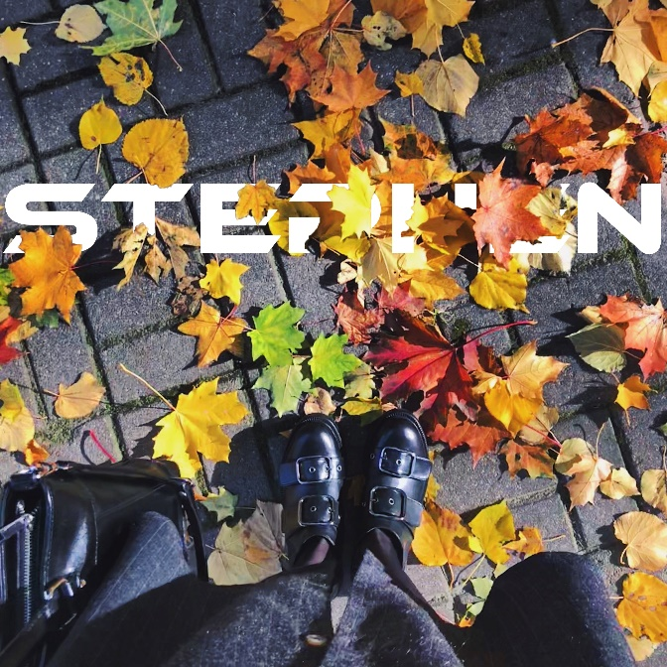

**Class Project 6: Image Background Blur**

1. **Image:** Use image from exercise file or you can use your own created image or you can use unsplash.com
2. **Duplicate Layer:** Duplicate background layer in layer panel
3. **Selection:** Select the new layer and use quick selection tool and make a selection of subject
4. **Add Layer Mask:** After selection create a layer mask of subject
5. **Convert for smart filters:** Select the layer mask in layer panel than go for filter menu and click on “convert for smart filters”
6. **Rename Layer:** Rename converted layer as “Mask”
7. **Blur Filter:** Select the background layer in layer panel than go for filter menu and then blur option than go for Gaussian blur filter
8. **Set Radius:** Set radius of Gaussian blur for 50px or as you want
9. **Output:** Save the image in JPEG format

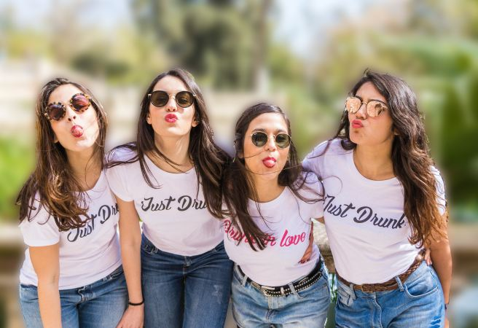

**Class Project 7: Remove Spot From Skin**

1. **Image:** Use image from exercise file or you can use your own created image or you can use unsplash.com
2. **Duplicate Layer:** Duplicate background layer in layer panel and rename as Retouch
3. **Spot Healing Brush Tool:** Use spot healing brush tool and place mouse cursor on spots and start removing spots. Mode should be Normal and Type should be Content Aware
4. **Output:** Save the image in JPEG format

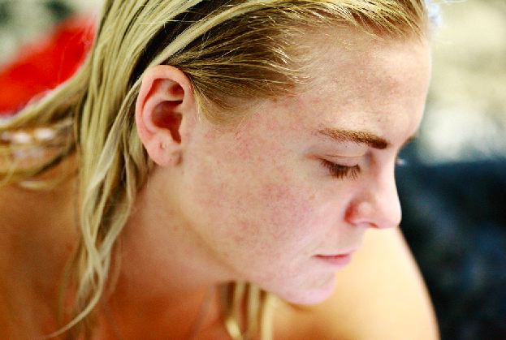

**Class Project 8: 3D Glass Effect On Image**

1. **Image:** Use image from exercise file or you can use your own created image or you can use unsplash.com
2. **Duplicate Layer:** Duplicate background layer in layer panel and rename as GB
3. **Unlock Background Layer:** Unlock or Rename background layer as R
4. **Blending Option:** Use blending for R layer and keep R channel active and make inactive G and B channel. Use blending option for GB Layer make G and B channel active and make R channel inactive
5. **Scale Image:** Select GB Layer and scale GB layer and move a little in right side
6. **Output:** Save the image in JPEG format

